

UNIVERSITY F AGRICULTURE, FAISALABAD
ENDOWMENT FUND SECRETARIAT
Ph. 041-9201125, 041-9200161-70 Ext. 3604 & 3607
www.efsuaf.org E-mail efs@uaf.edu.pk

A. EVENT ORGANIZER INFORMATION

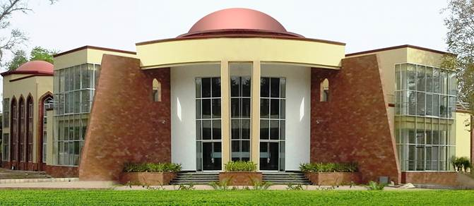
Organizer Name: __________________________________
Type of organization: □ Private □ Government □ UAF

National Tax Number: _____________________
Address: _________________________________________________
_________________________________________________
Tel: ________________________ Fax: ____________________
E-Mail: ________________________ Website: _________________

B. EVENT DETAILS

Event Title: ________________________________________________________
Event date & duration: _________________________________________________
Space/Halls required (clearly indicate Nos. with Floor):____________________________
Event Type:
1. Trade Exhibition □ 2. Consumer Fair □
3. Seminar/Conference/Convention □ 4. Workshop & Training □
5. Corporate Event □ 6. Cultural Carnival □
7. Others (mention) □

C. Event Objectives:
(Extra sheet may be attached)
D. Detail of Activities:
(Extra sheet may be attached)
E. Terms & Conditions:
- The booking will be made available on first come first serve basis.
- The organization should have National Tax Number or registered with any Government entity.
- Event Booking Advice will be issued to the Customer after getting approval of the event requisition from the Management of Exhibition Centre.
- For firm confirmation, 15 % of the total amount of booking advice will be deposited as a refundable security deposit.
- Full payment will have to be made at least fifteen days before the event. In case of any non-compliance, EC Management reserves the rights to impose penalty of Rs. 15,000/- for each day of delay or 5% of the invoice value for each day of delay, whichever is higher but up to five days before the event. In case full payment is not made, the booking will be cancelled and 15% security will be forfeited.
- Payments are acceptable through pay order/ demand draft in favor of Executive Director, EFS, UAF.
- Organizer will be responsible for N.O.C. / permission / payment and related dealings with City Government, etc. if any, in respect of event, advertising material, payment of excise duty, etc.
- EC Management reserves the right to allocate the dates to any other entity, without any further intimation if the 15% advance security is not received within seven days of the issuance of the booking advice.
- EC Management reserves the right to accept or reject the request without giving any reason.
- Organizer cannot charge any entry fee/ ticket without prior approval of EC Management.

- No organizer shall advertise any proposed event at Exhibition Centre unless booking is confirmed in writing, which will be issued after the receipt of 15% advance security amount from the organizer.
- Advertisements on stall by exhibitors will not contain any wording/statement of specific political/religious nature that may affect others and are against the State.
- Display of messages/pictures on stalls by exhibitors must be in accordance with the local, social, cultural and religious values.
- Exhibitor will be solely responsible for the protection of its products/accessories at stall during the exhibition time.
- Selling of food items & beverages will not be allowed at stalls
- Unauthorized music will not be allowed at the stalls.
- Prior permission from EC Management will be required for the use of echo sound systems for which the noise level should not be more than 6 d.b.
- Use of sub-standard stands and decoration tables / sub-standard counters in the stalls is not allowed and is subject to penalty.
- Drilling, nailing and use of any sticking material, which may damage the building, either by organizer or any of the exhibitors, is not allowed.
- The exhibitor forfeits the right of refund in case of cancellation of confirmed booking by the exhibitor.
- If required, the Exhibition Center Management Committee reserves the right to change the dates of event.
- In case of non compliance of any condition, Exhibition Centre management reserves the right to impose penalty of Rs. 25,000 or actual value of damage, whichever is higher
- The Exhibition Center Management Committee reserves the rights to accept or reject any space request without assigning any reason.

SUBMITTED BY

Name: _____________________________________________
CNIC: _____________________________________________ (please attach copy of CNIC)
Designation: _______________________________________
Cell #: _______________________ E-mail: _________________________________
Phone Number: ______________________ Fax Number _________________
Signature: ________________________ Date: _______________________

SPACE/HALLS AVAILABLE
A. Ground Floor
Sr.# | Exhibition Place | Covered Area (sq. ft.) | Tariff Rate per day  (lump sum)
1. | Hall No. 1 | 2064 | Rs. 40,000
2. | Hall No. 2 | 2223 | Rs. 45,000
3. | Hall No. 3 | 3128 | Rs. 60,000
4. | Hall No. 4 | 3128 | Rs. 60,000
5. | Hall No. 5 | 1463 | Rs. 30,000
6. | Hall No. 6 | 1463 | Rs. 30,000
7. | Hall No. 7 | 2223 | Rs. 45,000
8. | Hall No. 8 | 2064 | Rs. 40,000

B. 1st Floor
Sr.# | Exhibition Place | Covered Area (Sq. ft.) | Tariff Rate per day  (lump sum)
1. | Hall No. 1 | 2064 | Rs. 30,000
2. | Hall No. 2 | 2836 | Rs. 40,000
3. | Hall No. 3 | 3128 | Rs. 45,000
4. | Hall No. 4 | 3128 | Rs. 45,000
5. | Hall No. 5 | 3510 | Rs. 50,000
6. | Hall No. 6 | 2064 | Rs. 30,000

C. Optional Area
1. | Open area (for Exhibition, Food Street and other entertainments) | Rates negotiable
2. | University facilities like auditorium or other conference halls | As per University Rules

