

UNIVERSITY AGRICULTURE, FAISALABAD
ENDOWMENT FUND SECRETARIAT
Ph. 041-9201125, 041-9200161-70 Ext. 3604 & 3607 E-mail efs@uaf.edu.pk

(FOR UAF ONLY)
A. EVENT ORGANIZER INFORMATION

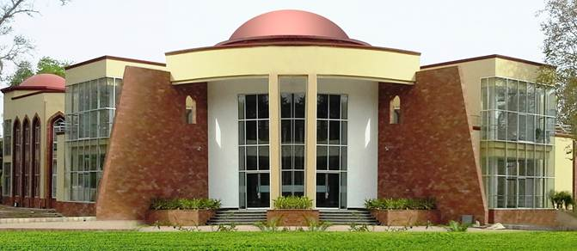
Organizer: __________________________________

Department: _________________________________________________
_________________________________________________
Tel: ________________________ Fax: ____________________
E-Mail: ________________________ Website: _________________

B. EVENT DETAILS

1. Event Title: ________________________________________________________
2. Event date & duration: _________________________________________________
3. Space/Halls required (clearly indicate Nos. with Floor):____________________________
4. Event Objectives:

5. Brief of Activities:

C. Terms & Conditions:
- The booking will be made available on first come first serve basis.
- Event Booking Advice will be issued to the Organizer after getting approval of the event requisition from competent authority.
- EC Management reserves the right to accept or reject the request without giving any reason.
- Organizer cannot charge any entry fee/ ticket without prior approval of EC Management.
- Advertisements on stall by exhibitors will not contain any wording/statement of specific political/religious nature that may affect others and are against the State.
- Display of messages/pictures on stalls by exhibitors must be in accordance with the local, social, cultural and religious values.
- Exhibitor will be solely responsible for the protection of its products/accessories at stall during the exhibition time.
- Selling of food items & beverages will not be allowed at stalls
- Unauthorized music will not be allowed at the stalls.
- Prior permission from EC Management will be required for the use of echo sound systems for which the noise level should not be more than 6 d.b.
- Use of sub-standard stands and decoration tables / sub-standard counters in the stalls is not allowed and is subject to penalty.
- Drilling, nailing and use of any sticking material, which may damage the building, either by organizer or any of the exhibitors, is not allowed.
- If required, the Exhibition Center Management Committee reserves the right to change the dates of event.
- The Exhibition Center Management Committee reserves the rights to accept or reject any space request without assigning any reason.

SUBMITTED BY

Name: _____________________________________________
Designation: _______________________________________
Signature: ________________________ Date: _______________________

Endorsement

CHAIRMAN/DIRECTOR DEAN

SPACE/HALLS AVAILABLE

A. Ground Floor
Sr.# | Exhibition Place | Covered Area (sq. ft.)
1. | Hall No. 1 | 2064
2. | Hall No. 2 | 2223
3. | Hall No. 3 | 3128
4. | Hall No. 4 | 3128
5. | Hall No. 5 | 1463
6. | Hall No. 6 | 1463
7. | Hall No. 7 | 2223
8. | Hall No. 8 | 2064

B. 1st Floor
Sr.# | Exhibition Place | Covered Area (Sq. ft.)
1. | Hall No. 1 | 2064
2. | Hall No. 2 | 2836
3. | Hall No. 3 | 3128
4. | Hall No. 4 | 4591
5. | Hall No. 5 | 3686
6. | Hall No. 6 | 2064

C. Optional Area
1. | Open area (for Exhibition, Food Street and other entertainments)
2. | University facilities like auditorium or other conference halls

